Land Auction
Estate of Willard W. "Mike" Sloss
200+/- Acres, Guthrie County, Iowa
- Saturday March 6th 2021 10:00 AM
Guthrie Activity Center-209 State St.-Guthrie Center Iowa
Auctioneer Comments: Mike purchased this farm in 1964 and moved his family here. He raised 3 children on this land along with a number of cattle, hogs, & chickens on this working family farm. Mike continued to live here until 2016 when his health forced him to leave the land. Willard passed away in 2020 and his family have made the decision to sell the farmland. The land will be offered in 2 parcels the West side Baker Twp. with 150 acres and the east side Valley Twp. with 50 acres.
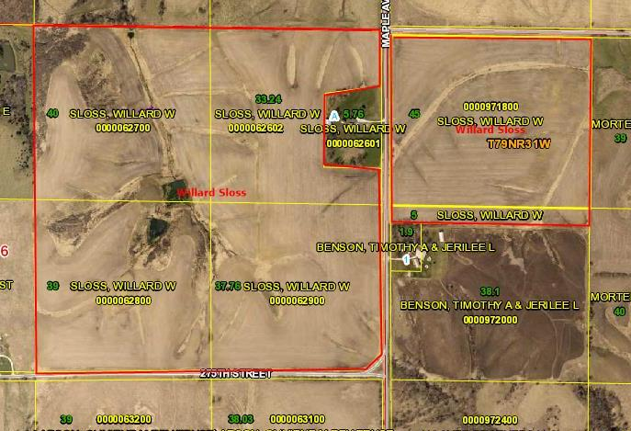
Tract I Tract 2
Tract I-West side Baker Twp.

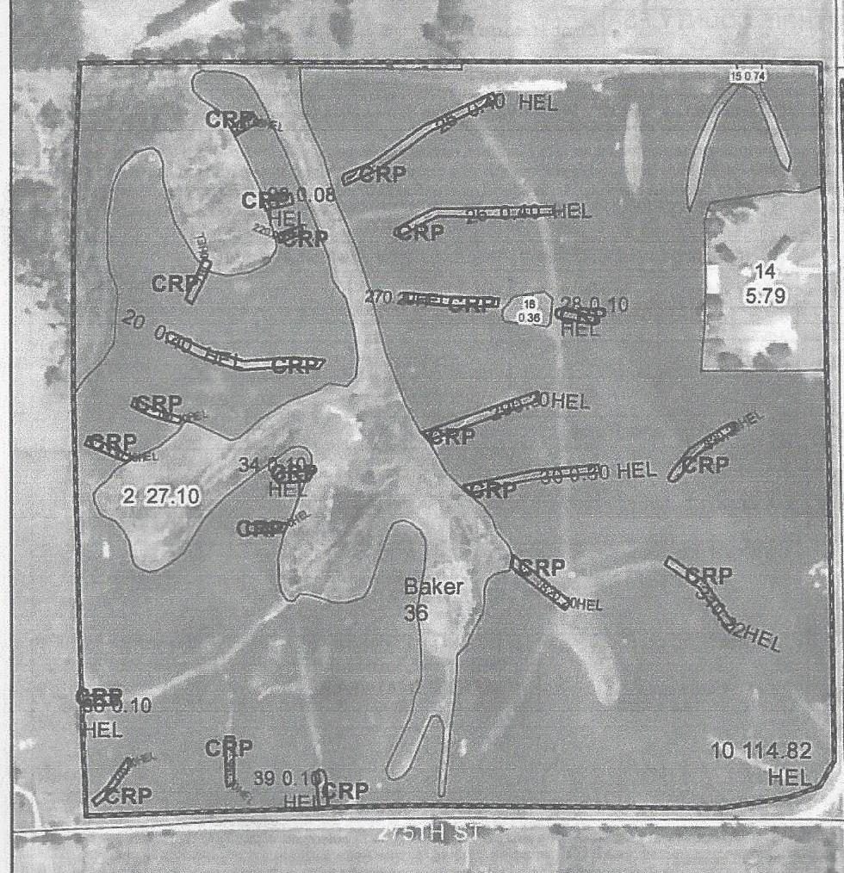
Tract 1--West side
This farm acre amounts are based on FSA
maps and Beacon, Guthrie County
Assessor's measurements and contains 150 acres.
- NE 1/4 Sec. 36 Baker Twp.Guthrie Co.
- 150+/- Acres 120.38 cropland acres
- 52.2 Corn Suitability Rating
- FSA Yields Corn 104-Beans 42
- Property Location: From Guthrie Center 4 miles South on Hwy 25 to 270th St. West 1 mile to Maple South, land lies on West side of road look for signs
- CRP contract 3.84 Acres @$182.67 per acre thru Sept. 30, 2021

Legal Descriptions: NW1/4 NE1/4 , SW1/4 NE1/4, NE1/4 NE 1/4 Except "Parcel A" thereof,
SE1/4 NE1/4 all in Section 36, Twp 79 N R32- W. 5th P.M., Guthrie Co. Iowa.

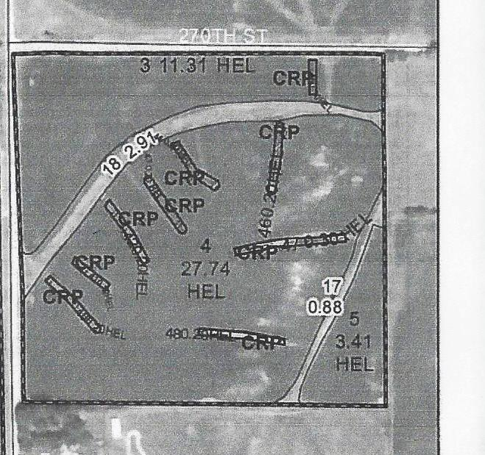
Tract 2-East Side
This farm acre amounts are based on FSA
maps and Beacon, Guthrie County
Assessor's measurements and contains 50 acres.

- 50+/- Acres 42.46 cropland acres
- 59.6 Corn Suitability Rating
- FSA Yields Corn 104-Beans 42
- Property Location: From Guthrie Center 4 miles South on Hwy 25 to 270th St. West 1 mile to Maple South, land lies on East side of Maple & South side of 270th. road look for signs
- CRP contract 1.72 Acres @ $182.67 per acre thru Sept. 30, 2021

Legal Descriptions: NW Fractional Quarter & N. 4.91 acres of the SW Fractional 1/4 of the NW 1/4 of Section 31, Twp. 79, Range 31, All West of the 5th P.M., Guthrie County, Iowa

Plat Matt
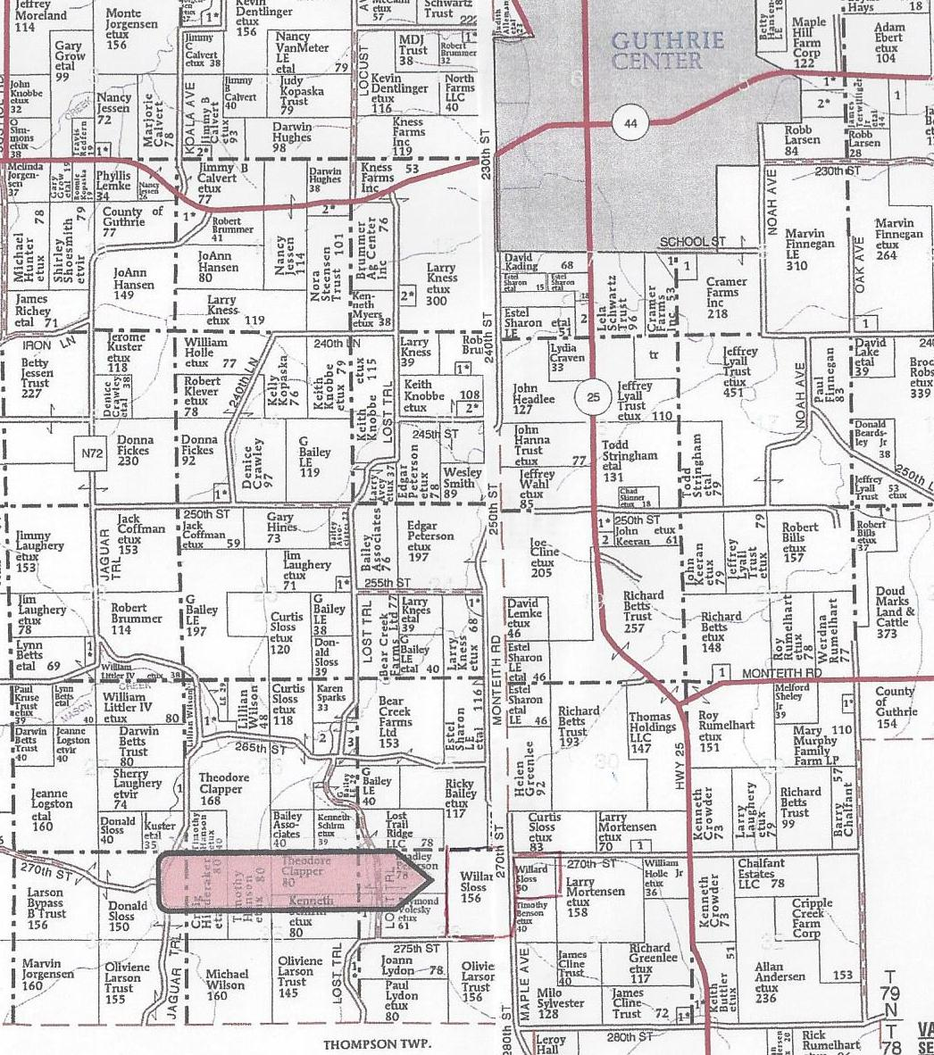
Platte Map and Directions to farm.

Auction Terms
Sale Method: The real estate will be offered in 2 tract. All bids are open for advancement until the auctioneer announces that the real estate is sold and the bidding for that tract is closed. Prior approval is required on all Absentee bids or phone bids. Final sale is subject to seller's approval or rejection.
Agency: Wedemeyer Auction & Realty and its agents are acting as agents for the sellers.
Announcements: Information provided is deemed reliable from all sources. Wedemeyer Auction and Realty & the sellers make no guarantees or warranties as to the accuracy of all stated facts. All potential buyers are urged to make your own inspections and to conduct your own investigations and follow your own conclusions. All sketches dimensions and measurements are listed as more or less. Any announcements auction day take precedence over printed materials or oral statements. Wedemeyer Auction and Realty reserve the right to reject any bids from persons or persons deemed unqualified to fulfill a real estate contract.
Closing: will be approximately March 30, 2021 or on a date in agreement to all parties. The balance of the purchase price will be payable at closing in (guaranteed funds) cash or by wire transfer at the discretion of the closing attorney, Beverly Wild of Wild Baxter & Sand PC
Possession: will be upon closing- landlord/tenant lease has been terminate prior to sale date.
Taxes: Taxes will be prorated to the date of closing Tract 1 (West side) estimated taxes $2552 Annual amount. Tract 2 (East side) taxes $964 Annual amount.
Minerals: All mineral rights will be conveyed by the Seller.
Conditions: Sale is subject to all easements of record, and leases. Each bidder is responsible for inspections and inquiries and due diligence concerning the property. Earnest Payments: 10% down day of sale with balance upon closing estimated March 30, 2021
Contract & Title: Immediately upon conclusion of auction the successful bidder will enter into a real estate contract and provide the required earnest deposit. The seller will provide buyers with a current abstract of title at their expense. Sale is not contingent upon Buyers Financing. Buyers will have all financing arrangements pre-arranged and in place the day of sale.
Survey: The parcel will use the existing survey and no new survey will be ordered by sellers.
Wedemeyer Auction & Realty and our agents and staff understand the importance of staying safe thru this Covid-19 outbreak. With this in mind we want to remind auction attendees as well as our staff to practice social distancing & proper hygiene while in larger group settings as outlined by local, state and federal agencies. attendees are urged to bring their own mask. We want our clients and attendees to stay safe. If you are not feeling well stay home. We will see you at the next auction.



Auction & Realty LLC
www.wedemeyerLLC.com e-mail info@wedemeyerLLC.com
Doug Wedemeyer Auctioneer Judy Wedemeyer Real Estate Broker
641-740-0102 641-746-2720

